**User Management stuff from SD side**

Our customer SD wants direct Login for the operator user. To switch to the service user a logout of the operator has to be done and the credentials has to be entered of the service user. A service user has the rights to add other users as well as changing password of those. As operator there will be no possibility anymore to change password. When there are more than one operator the login screen has to be shown because the system couldn’t decide which operator to choose for the direct login. For the operator nor the expert should be show personal settings and user administrations.

**NOTE:** Our customer SD didn’t have an Expert user level.

**Current Situation**

Direct login is already working with current set up if we have only one user in the system and this is our service user.

**What we need to do?**

We need to adjust the Auto Login feature which needs to fit our customer requirements.

Need a configuration setup for enable/disable this feature, because we are not sure other customer would also expect the same?

**Adjust the Personal Settings View**

**MI: I would do that in a different way. I would take the user administration view add a button change password of selected user. Either this button leads to an adjusted personal settings view or enables a group box for changing the password directly on the user administration view.**

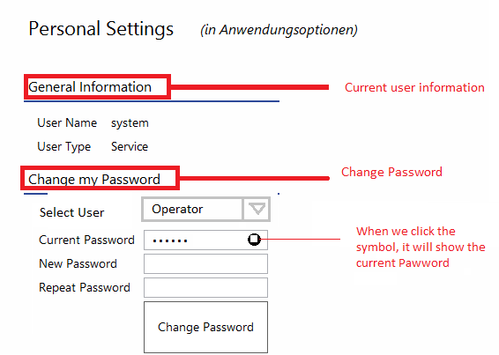

**Adjust Person Settings View Model**

* Implement the feature visibility, because we should allow changing the other’s password by service user not for the operator.
* Implement the password string visibility (hash coded password to original password).

**Adjust the Logout function**

Currently it’s simply logout the current user and displays the login screen.

To Do:

* Check the current user, if he/she is an operator, and then switch to service user and vice versa.
* If we switch to service, ask the login credentials.
* If we switch to operator, check if we have multiple operators then ask credentials, otherwise direct login option enable.

**Adjust the Auto Login function**

Currently its do the auto login when we have a single user and that too it has an operator user.

To Do:

* Do auto login if we have only one operator but we have other type operators.
* Keep the previous state.
* Need a configuration switch like “IsOperatorAllowToDirectLogin” or something the use this switch in the Auto login feature.

**Things to Check**

**IMPORTANT:** Please check the system also with Air-Conditioned room UI.

**Operator**

* If only one operator in the database i.e. we can have other type of user, Do the direct login.
* If multiple operators, Do the Login first.
* Should not allow the admin stuff.
* Should allow to change the own password not for other’s
* Should not allow changing the other type of user’s password.
* If we have only one operator i.e. we don’t have any other type of user, do not allow switching user.
* If we have more users, then allow to switching the user.

**Service**

* Allow to do the administration stuff.
* Allow to change the password for other type of user’s
* Ask the credentials while switching.